Personal Information

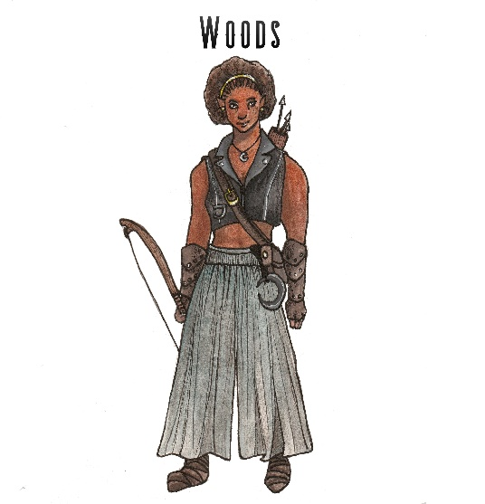
Name (Last Name, First): Mellwood
Preferred Name: Woods
Age: 135
Ethnicity: Wood Elf
Gender: Female
Marital Status: Single
Town/City of Birth: Apacure
Town/City of Citizenship: Apacure
Employment History
Have you ever been a member of “The Order of Light”? No
If yes, provide clarification as to when you left the membership and for what reason?

Previous Employer: delRay Sanctuary
Profession/Job Title: high priestess training
Town/City of Employment: Apacure
Reason for Leaving: to apply here
What applicable skills did you learn in this position that you feel will benefit you in your work as a Knight of the Order?
While this wasn’t a job, it was what I did for a living. I trained to be a high priestess for Solpelor, the Sun God. Training taught me great discipline, and deviation.
Who may we contact to verify your employment, list any that would apply?
please do not contact delRay

Membership Profile
What has drawn you toward joining the Order? It’s all I have left. I couldn’t stay where I was, and I have this gift now. I need to use it for good. It’s the only way I know how to fight for Her.

When/how did you discover you have the Gift of the Light? (We may Role Play these sessions out)
a rift opened in my village, I got on my knees to pray, and Lucha, the Moon god came to me. she said she could help me save my village. she gave me this gift.

What is your family Dynamic? Is your family proud of you for joining the Order?
My family sees this as Vanity and fame. The worse thing an Elf can do. one of the highest sins in our culture. however they don’t know the true reason I’m here.

What do you most love? What do you most want to protect?
this land and all the things that live on it.

What do you most fear?
losing my family forever.

What do you most regret? What would you have done differently?
I wish I would have run, I wish I would have just run away from the Rift. Had I not prayed, had I not tried to help, I would still be with my family. But I didn’t do that. So, this is where I am. And I have to face what that means.

As a child where did you like to go? What were your favorite places?
Thorpe lake, swimming and being with my family.

Outside of your work history, what other life experiences have given you skills that would make you a great Knight in the Order of Light?
I am really strong and athletic, but also passionate and care about all living things.

Where do you see yourself in five years? 10 Years? In retirement?
I’d like my family to love me again. I’d love to make them proud. I’d like to be able to be back with them.

What are your biggest weaknesses?
I am stubborn when I don’t get my way.

Do you have any friends or family members, whom we should contact to join the Order of the Light?
None

