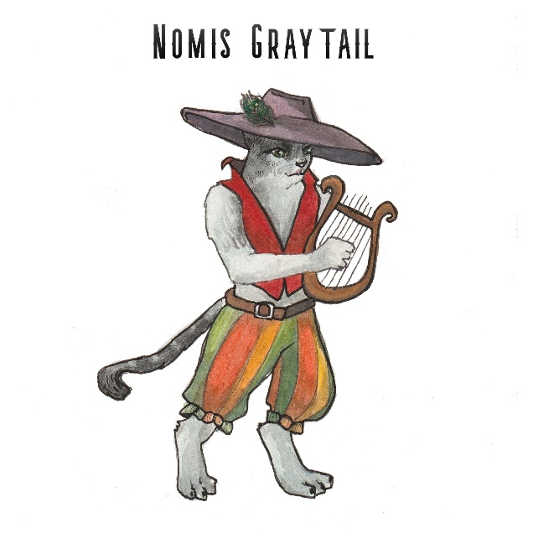
Personal Information

Name (Last Name, First): Nomis Graytail
Preferred Name: Nomis
Age: 25
Ethnicity: Tabaxi
Gender: Male
Marital Status: Single
Town/City of Birth: Unknown
Town/City of Citizenship: Wherever the road takes me
Employment History
Have you ever been a member of “The Order of Light”? NO
If yes, provide clarification as to when you left the membership and for what reason?

Previous Employer: G & R’s Traveling Tabaxi Troup
Profession/Job Title: Entertainer extraordinaire! Performer, dancer, musician, singer and more!
Town/City of Employment: Whatever city welcomes us!
Reason for Leaving: *See back story below*
What applicable skills did you learn in this position that you feel will benefit you in your work as a Knight of the Order?
Several! While boosting morale with my performance arts, I can also produce a magical light that will send the dark creatures of the rifts back into the darkness that they came from.
Who may we contact to verify your employment, list any that would apply?
If you can find them, as they travel from city to city: My father Lionel Graytail and his partner Garf Ragamuffin

Membership Profile
What has drawn you toward joining the Order? Not so much drawn towards joining, but heavily suggested by Nix, a maiden of the fey diety Valdana. My ultimate purpose is to gain the ability and strength to fight off this evil so that I can save my friend Grace Ragamuffin.

When/how did you discover you have the Gift of the Light?
When my troupe was attacked while on the road a rift opened. Instinctively I grabbed my Lute and strummed a cord and a light released from me closing the rift. But I lost consciousness after the event.

What is your family Dynamic? Is your family proud of you for joining the Order?
As tabaxi, we are very close knit to our families and support one another through thick and thin. So yes, my family is very proud of me for joining the order to save several of our own.

What do you most love? What do you most want to protect?
I love performing and sharing my music for everyone to hear. I most want to protect my family and troupe, and to return Grace Ragamuffin to me.

What do you most fear?
Booing and disapproval of the crowds when I play my music. And water! I can’t stand water!!!

What do you most regret? What would you have done differently?
I most regret not telling Grace my true feelings for her. She’s more than just a friend to me, if you can pick up what I’m putting down. Naturally, I would have worked up the courage to tell her my true feelings before all this happened to her.

As a child where did you like to go? What were your favorite places?
The bigger the city the better! I enjoy meeting new people and performing for new faces. I also enjoy learning about other cultures and groups and experiencing their practices, traditions, music and cuisine!

Outside of your work history, what other life experiences have given you skills that would make you a great Knight in the Order of Light?
Traveling and living on the road. Surviving the elements, foraging for food, water and wood for the fire. I am also very “cultured” and know my way around several cities.

Where do you see yourself in five years? 10 Years? In retirement?
I ultimately see myself and Grace becoming well known across the realm, performing our music for everyone. Perhaps one day we will have a family of our own and as I become older can impart my love and gift of music to a new generation.

What are your biggest weaknesses?
It is sometimes hard for me to pay attention. I get easily distracted or my “cat” instincts will kick in and I will want to chase a light or play with a piece of string. I often find that playing my music and meditation helps to stay focused.

Do you have any friends or family members, whom we should contact to join the Order of the Light?
Any of the contacts I provided in my troupe, should you be able to find them, will certainly vouch for my loyalty and dedication to this cause.

