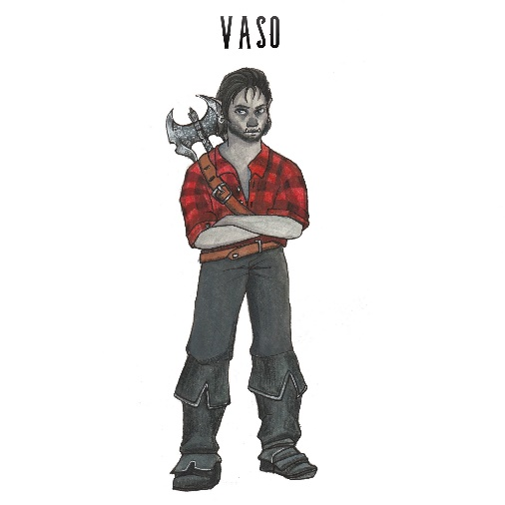
Personal Information

Name (Last Name, First): Vasso ‘The Farmers Son’
Preferred Name: V
Age: 17
Ethnicity: Half Orc
Gender: Male
Marital Status: Single
Town/City of Birth: Amberton
Town/City of Citizenship: Amberton
Employment History
Have you ever been a member of “The Order of Light”? No
If yes, provide clarification as to when you left the membership and for what reason?

Previous Employer: Dad’s Farm
Profession/Job Title: Farmers Assistant
Town/City of Employment: Amberton
Reason for Leaving: To use the gift of the light for the greater good
What applicable skills did you learn in this position that you feel will benefit you in your work as a Knight of the Order?
I can chop wood, grow crop, raise livestock, cook
Who may we contact to verify your employment, list any that would apply?
My dad

Membership Profile
What has drawn you toward joining the Order?
The place I was born and grew up in is not very accepting of me, so I am looking for a change. Also, I was recommended when I fought the De-know-a in my town.

When/how did you discover you have the Gift of the Light? (We may Role Play these sessions out)
When the De-know-a showed up in my hometown, I saw the leader of the local Order fall, so I stepped up and was able to cast a shield to help fight off the enemy.

What is your family Dynamic? Is your family proud of you for joining the Order?
My father wanted me to stay home, to stay safe and run the family farm

What do you most love? What do you most want to protect?
My father

What do you most fear?
Spiders

What do you most regret? What would you have done differently?
The time I embarrassed myself in front of a pretty girl. I wouldn’t have tripped and fallen right in front of her and her friends.

As a child where did you like to go? What were your favorite places?
I liked to stay at home. Also, doing work around the farm is nice. No one around to stare at my tall and skinny looks

Outside of your work history, what other life experiences have given you skills that would make you a great Knight in the Order of Light?
I was a farmer growing up.

Where do you see yourself in five years? 10 Years? In retirement?
5 years- Traveling the world and on an adventure.
10 years- I don’t know
What’s retirement?
What are your biggest weaknesses?
I’m self-conscious and shy.
Do you have any friends or family members, whom we should contact to join the Order of the Light?
Not that I know of. I’m an only child. My father is a farmer and my mother left us when I was an infant.

